**INTRODUCTION**

**1.1 OVERVIEW**

### *“*How To Create A Landing Page In Hubspot”

"In the realm of digital marketing, crafting a compelling landing page is pivotal for converting visitors into leads and customers. HubSpot offers a streamlined solution for this task, providing a user-friendly platform that empowers marketers to design and launch effective landing pages with ease. Leveraging HubSpot's selection of customizable templates and intuitive drag-and-drop editor, you can create visually stunning and conversion-focused landing pages. Seamlessly integrate forms, multimedia elements, and persuasive copy that align with your brand's messaging. HubSpot's built-in CRM integration simplifies lead management, while its A/B testing capabilities enable continuous optimization for higher conversion rates. Gain actionable insights through robust analytics, allowing you to refine your landing pages and achieve exceptional results in your digital marketing efforts."

**1.2 PURPOSE**

* Boost your credibility: Users typically appreciate clear, simple messaging that explains the value of what you’re offering. A well-planned landing page [shows your customers that you have their best interests in mind](https://mailchimp.com/resources/customer-service-philosophy/). They’re also places where you can insert testimonials about your product or service, which are an element of social proof. Social proof has been shown to increase conversions.
* Reinforce your brand: You’ve already put in the work to [build a digital brand](https://mailchimp.com/resources/build-strong-digital-brand/), so use what you’ve learned. This is the result of maintaining consistency in your website’s appearance, tone, style, and copy. Having a clear and strong brand has several benefits. When your users don’t convert immediately, a strong brand identity can help them remember you in the future, respond to your remarketing efforts, or recommend you to their friends.
* Generate leads: Both types of landing pages can generate leads for your business and increase sales. Landing pages are more targeted, allowing them to focus on conversion rates rather than education and information. Instead, you can highlight the features of your products and services and sell more to a targeted audience that’s already interested in your offerings.

**2. PROBLEM DEFINITION & DESIGN THINKING**

**2.1 EMPATHY MAP**

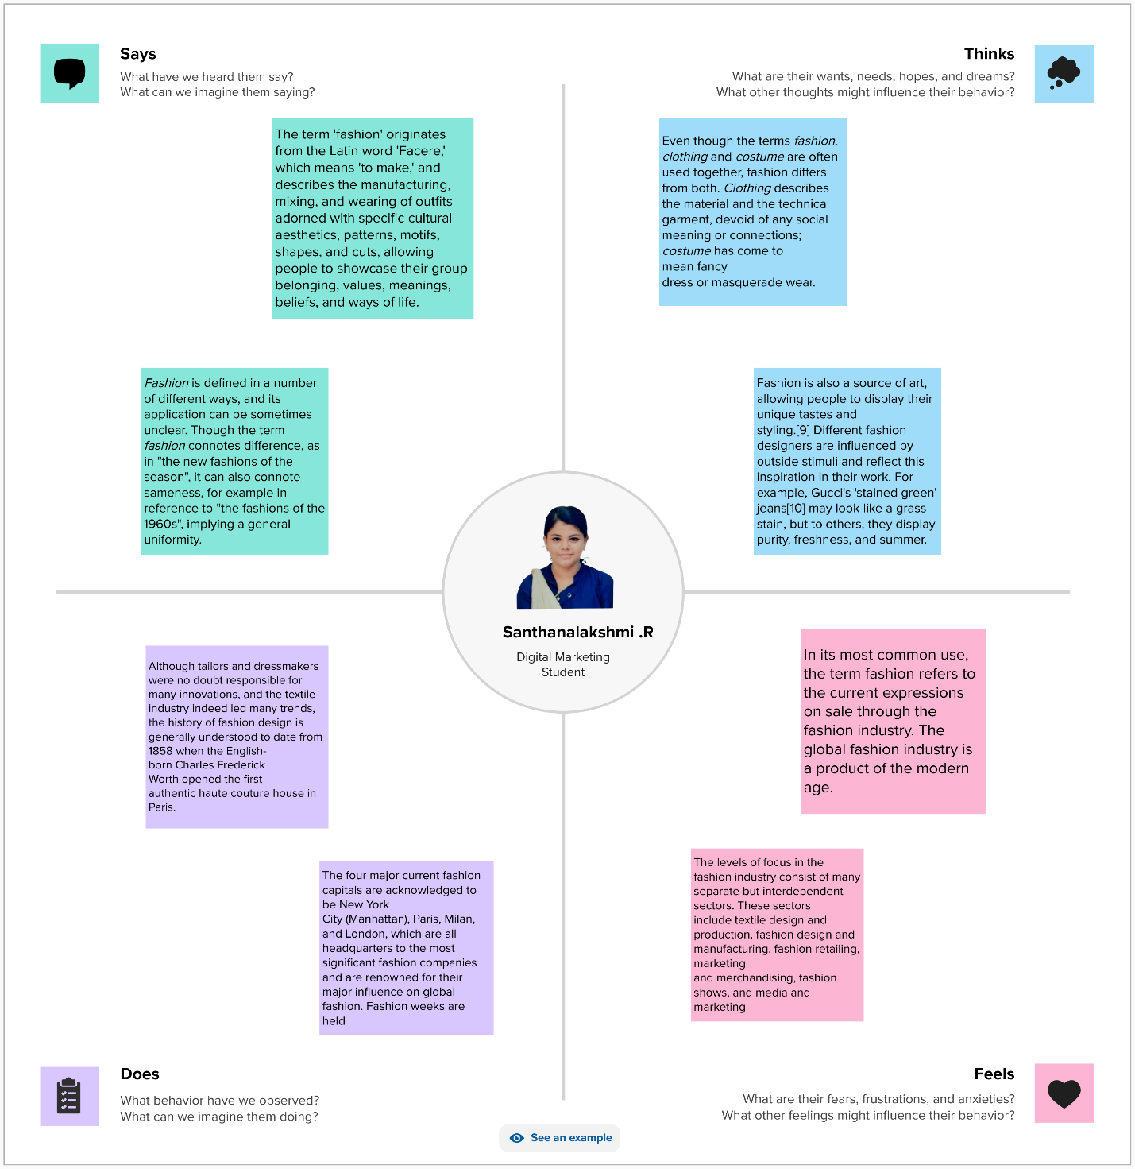

**2.2 IDEATION & BRAINSTORMING THINKING**

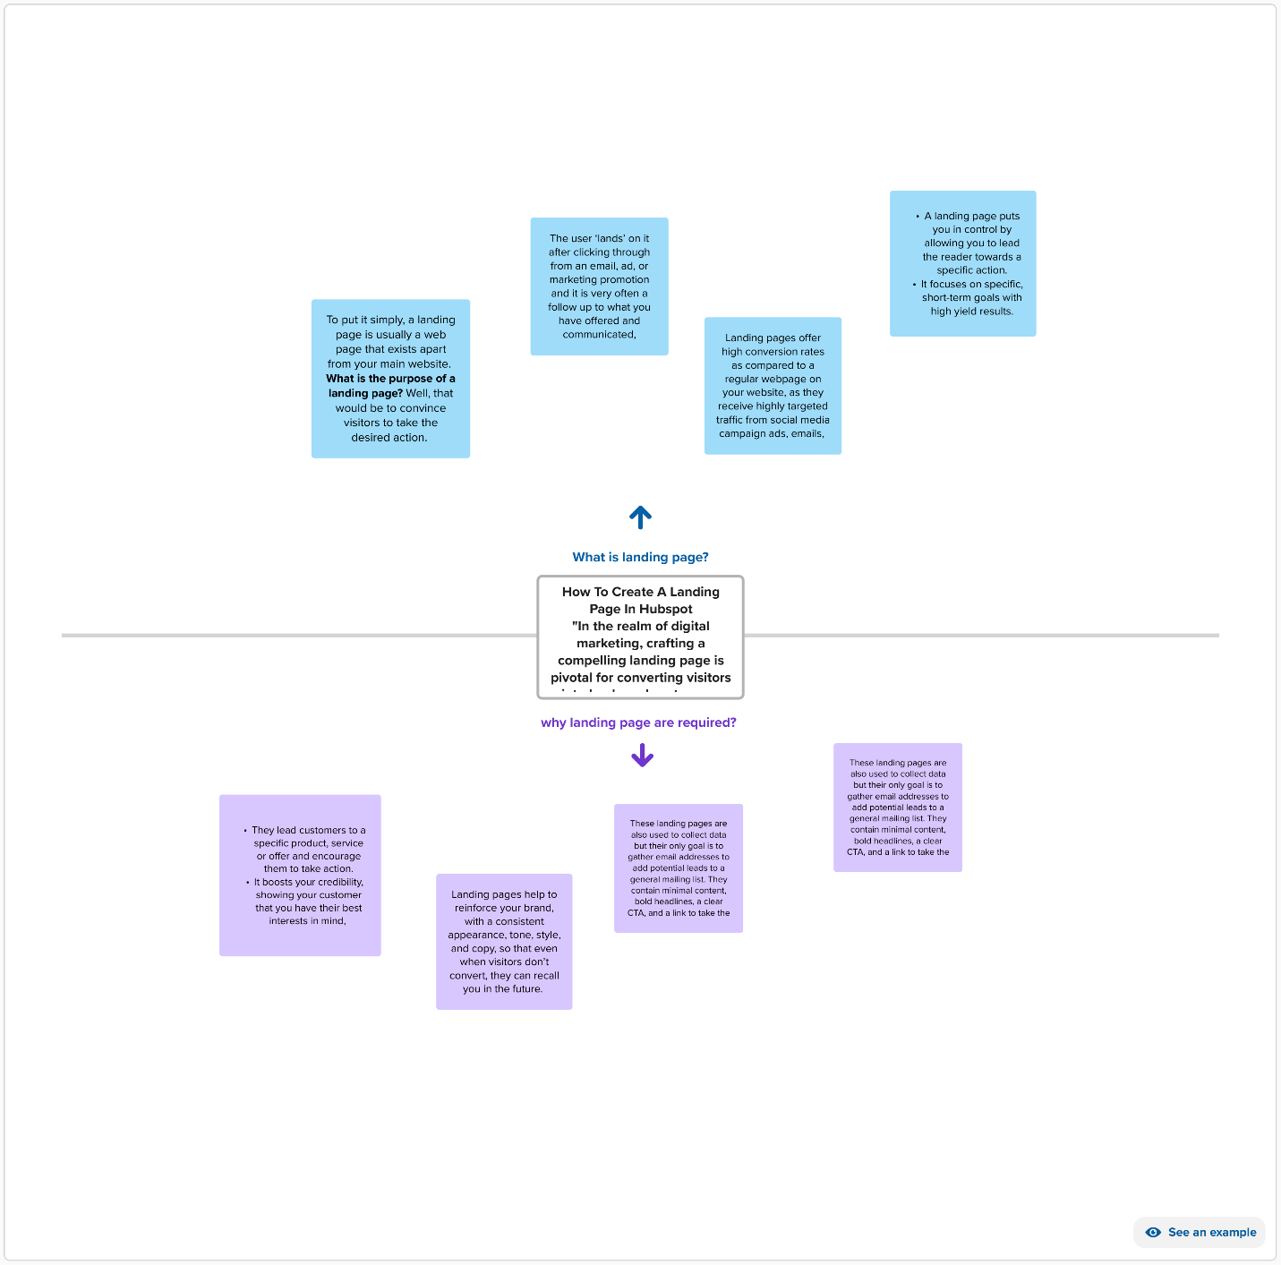

**3. RESULT**

**WEBSITE LANDING PAGE**

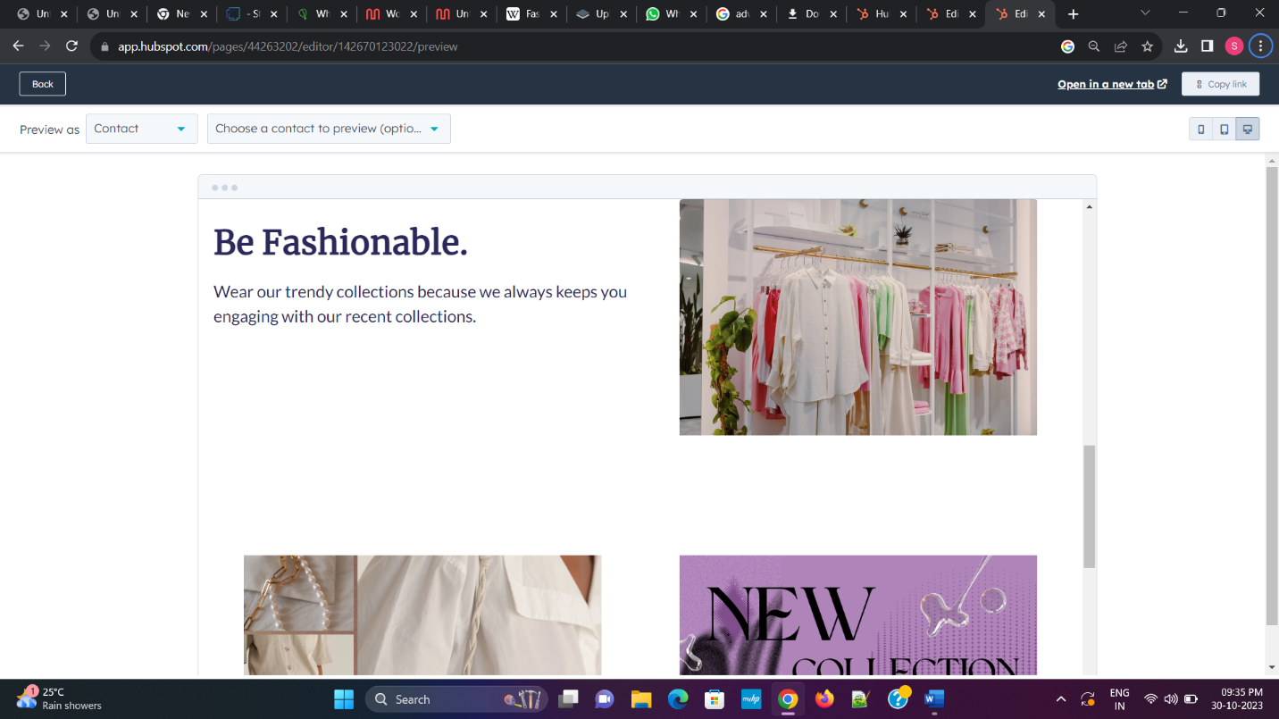

**BRAND NAME :** WhiteWolfClothing

**BRAND WEBSITE :** <http://www.whitewolfclothinghubspot.com/whitewolfclothing>

**4. ADVANTAGES & DISADVANTAGES**

**ADVANTAGES**

* User-friendly platform: Canva's intuitive interface makes it accessible to users with limited graphic design experience.
* Cost-effective: Canva offers a range of free and premium options, making it a budget-friendly choice for individuals and small businesses.
* Streamlined design process: The guide simplifies the branding process, providing step-by-step instructions for creating a cohesive brand identity.
* Promotes coherence: Emphasizes the importance of maintaining consistency and coherence across the brand name, brand mail, and logo, fostering a professional and unified brand image.

**DISADVANTAGES**

* Limitations of templates: While Canva offers a variety of templates, the pre-existing options may limit the originality and uniqueness of the final brand identity.
* Potential legal issues: The guide might not fully address trademark and copyright considerations, leaving users vulnerable to legal challenges if the brand name or logo inadvertently infringes on existing trademarks.
* Creativity constraints: Relying solely on Canva's tools may restrict the creative potential of the brand identity, especially for users seeking highly customized and unique designs.

**5. APPLICATIONS**

* + Entrepreneurs: Those starting a new business can utilize the guide to develop a unique brand identity that resonates with their target audience, thus enhancing brand recognition and recall.
* Small businesses: Small businesses can leverage the guide to create a professional brand identity that sets them apart from competitors and builds credibility within their industry.
* Freelancers and solopreneurs: Individuals offering freelance services or operating as solopreneurs can benefit from the guide to develop a professional brand image, enabling them to effectively market their services and establish a strong online presence.
* Content creators: Bloggers, vloggers, and social media influencers can use the guide to create a consistent and visually appealing brand identity that helps them connect with their audience and build a loyal following.
* Non-profit organizations: Non-profits seeking to enhance their visibility and credibility can follow the guide to develop a cohesive brand identity that effectively communicates their mission and values to potential supporters and donors.

**6. CONCLUSION**

In conclusion, "Create a Brand Name, and in Hubspot"serves as a valuable resource for individuals and businesses seeking to establish a strong and cohesive brand identity. By offering a systematic approach to branding using Canva's user-friendly platform, the guide empowers users to create a unique and professional brand presence that resonates with their target audience. While emphasizing the importance of coherence and consistency, the guide encourages users to think strategically about their brand's values and messaging. However, it is essential for users to be aware of the limitations of pre-existing templates and tools, as well as the potential legal implications of brand creation. Overall, the guide equips users with the necessary knowledge and practical steps to develop a compelling brand name, brand mail, and brand logo that effectively communicate their brand's essence and values.